
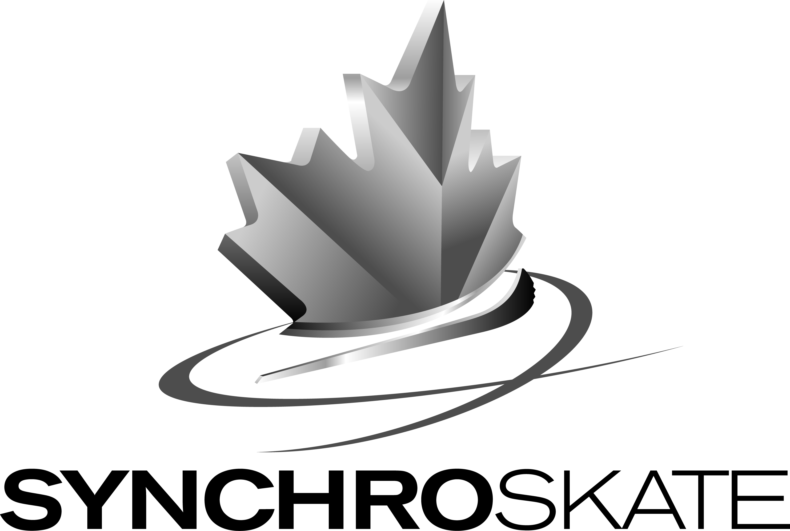

ENTRY CONFIRMATION SHEET

2013 MOUNTAIN REGIONAL SYNCHRONIZED SKATING CHAMPIONSHIPS

Team Name: _____________________________

Skate Canada Number: _____________________________

Registration will only be accepted if teams have completed the online portion of the registration process and submit all required fees and hard copy entry forms (signed by all participants) as outlined in the Regional Event Announcement.

Category (check):
- Beginner I

- Beginner II
- Elementary
- Juvenile
- Novice
- Intermediate
- Open
- Senior
- Adult I
- Adult II

- Pre-Novice
- Junior
- Adult III

Number of skaters on team _____*
*This number must match the number of signed waiver forms received.

Entry Fee: $25.00 (per skater) x ______ (# of skaters) + $375.00 (per team)

= $ ______

Team Contact:
Name: _____________________________
Title/Role: _____________________________
Email: _____________________________
Phone: _____________________________

___ Check (√) to confirm that the team manager, coach or club will complete Step 2 of the registration process online by December 14, 2012. The Online Event Registration Instructions are attached to the Regional Event Announcement as Appendix D.
All registration packages (including entry fee and required forms signed by all participants and parent/guardian if applicable) must be returned by December 14, 2012 to:

Name: BC/YT Section – Skate Canada
Attn: Danielle Williams
Address: #2 – 6501 Sprott Street, Burnaby, B.C., V5B 3B8
Phone: 604-205-6960
Fax: 604-205-6962
Email: danielle@skatinginbc.com

*The online registration portion must also be completed by the date specified above.

Note: Junior and Senior teams receiving a “Bye” through the Regional qualifying competition will still be responsible for submitting the required forms and entry fees to the Regional Organizing Committee by the entry deadline.

