**TOTEM**

**ANNOUNCEMENT**

**February 13 – 15, 2015**

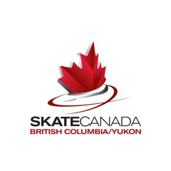****

**HOSTED BY: MILE ‘O’ FSC**

BC/YT SECTION

SUMMERSKATE COMPETITION

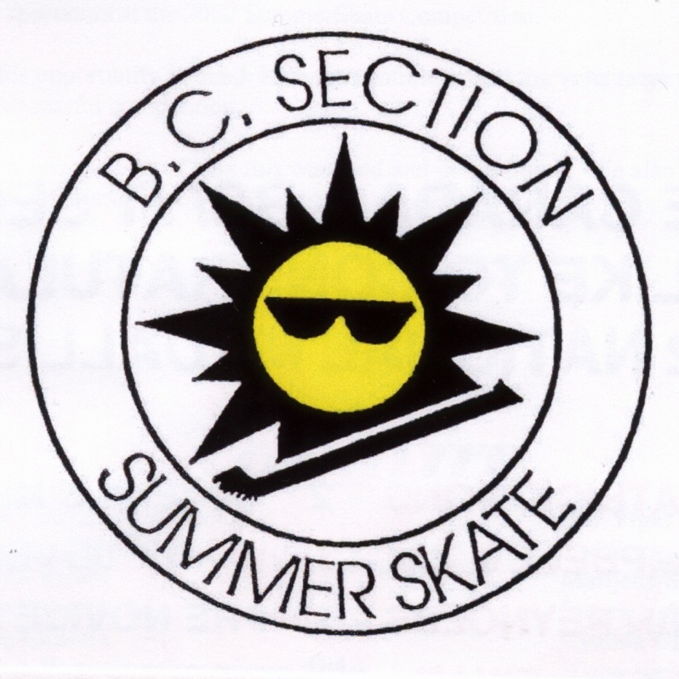

AUGUST 18th – 21st, 2011

Burnaby Ice Sports Centre

6501 Sprott Street

Burnaby, BC

V5B 3B8

**Hosted by the**

**MILE “O” FIGURE SKATING CLUB**

[**Online registration**](http://www.karelo.com/register.php?BID=477&BT=10&Ev=14893) **must be completed by 11:45 pm, Sunday, January 18, 2015. Instructions for entering on line can be found on Page 6 of this Announcement.**

**DATE:** February 13 – 15th, 2015

**HOST:** Mile “O” Figure Skating Club

**VENUE: Encana Events Centre**

**#1 300 HWY 2**

**Dawson Creek, BC**

**Kin Arena**

**1107 – 16th Ave**

**Dawson Creek, BC**

**ICE SURFACE: Encana Events Centre - Ice Surface 200 x 80 feet**

**Kin Arena Ice Surface - Ice Surface 200x 80 feet (rounded corners)**

**REGISTRAR: Marilyn Kreuzinger**

**kreuzfam@gmail.com**

**Phone – 250-782-5683**

**1513 – 116th Ave**

**Dawson Creek, BC**

**V1G 4G0**

**Karelo Registration Questions:** Cheryl Walters

Email: [kcwalters@shaw.ca](mailto:kcwalters@shaw.ca)

**TECHNICAL INQUIRIES:**  Marilyn Kreuzinger [kreuzfam@gmail.com](mailto:kreuzfam@gmail.com)

**EVENTS TO BE HELD & ENTRY INFORMATION**

|  |  |  |  |  |
| --- | --- | --- | --- | --- |
| STAR 1 | Girls | Boys | | $50.00 |
| STAR 2 | Girls | Boys | | $65.00 |
| STAR 3 | Girls | Boys | | $65.00 |
| STAR 4 | Girls U10 | Boys U10 | | $75.00 |
| STAR 4 | Girls U13 | Boys U13 | | $75.00 |
| STAR 4 | Girls 13 & O | Boys 13 & O | | $75.00 |
| STAR 5 | Girls U10 | Boys U10 | | $75.00 |
| STAR 5 | Girls U13 | Boys U13 | | $75.00 |
| STAR 5 | Girls 13 & O | Boys 13 & O | | $75.00 |
| Senior Bronze Free Skate | Women | Men | | $75.00 |
| Junior Silver Free Skate | Women | Men | | $75.00 |
| Senior Silver Free Skate | Women | Men | | $75.00 |
| Gold Free Skate | Women | Men | | $75.00 |
| Pre Juvenile | Women U11 | Men U11 | | $75.00 |
| Pre Juvenile | Women U14 | Men U14 | | $75.00 |
| Juvenile | Women U11 | Men U11 | | $75.00 |
| Juvenile | Women U14 | Men U14 | | $75.00 |
| Pre Novice | Women U16 | | Men U16 | $110.00 |
| Novice | Women U17 | | Men U17 | $110.00 |
| Pre Introductory Interpretive | Combined Women & Men | | | $70.00 |
| Introductory Interpretive | Combined Women & Men | | | $70.00 |
| Bronze Interpretive | Combined Women & Men | | | $75.00 |
| Silver Interpretive | Combined Women & Men | | | $75.00 |
| Gold Interpretive | Combined Women & Men | | | $75.00 |
| *Couples Introductory Interpretive |  | | | $40.00 /per skater |
| *Couples Bronze Interpretive |  | | | $40.00 /per skater |
| *Couples Silver Interpretive |  | | | $40.00 /per skater |
| *Couples Gold Interpretive |  | | | $40.00 /per skater |
| Intro Elements | Combined Women & Men | | | $35.00 |
| Elements 1 | Combined Women & Men | | | $35.00 |
| Elements 2 | Combined Women & Men | | | $35.00 |
| Elements 3 | Combined Women & Men | | | $35.00 |
| Open Elements | Combined Women & Men | | | $35.00 |
| **Junior Bronze Solo Pattern Dance | Combined Women & Men | | | $45.00 |
| **Senior Bronze Solo Pattern Dance | Combined Women & Men | | | $45.00 |
| **Junior Silver Solo Pattern Dance | Combined Women & Men | | | $45.00 |
| **Senior Bronze Solo Pattern Dance | Combined Women & Men | | | $45.00 |
| **Gold Solo Pattern Dance | Combined Women & Men | | | $45.00 |
| Special O Level 1 |  | | | $60.00 |
| Special O Level 2 |  | | | $60.00 |
| Special O Level 3 |  | | | $60.00 |
| Special O Level 4 |  | | | $60.00 |
| Special O Level 5 |  | | | $60.00 |
| Special O Level 6 |  | | | $60.00 |

* Couples Interpretive Categories(to replace Freeskate Pairs) – a couple may consist of 2 women, 1 woman and 1 man or 2 men. Note rules relating to STARSkate illegal elements and/or movements apply to this category.

**Note that the Solo Dance events are the STARSkate Dance categories – not the Skate Canada Pilot Solo Dance categories. Test requirements and dances to be skated for Junior Bronze to Gold are posted on the Totem Competition Page of the Skating in BC website.

Entry fees shall be refunded only if the competition is not held or if the entry is withdrawn before the closing date of entry. *NO REFUNDS WILL BE GIVEN AFTER THE CLOSING DATE OF ENTRIES OF THE COMPETITION (January 18, 2015) FOR ANY REASON WHATSOEVER. (Skate Canada Rule 7000 A 1.5 (2)).*

**Competition Surcharge is now included in the fees. All payments must be made online at the time of registration.**

## LATE ENTRIES WILL BE ACCEPTED AT THE DISCRETION OF THE LOC AND WILL BE CHARGED DOUBLE THE ENTRY FEE.

[Online Registration](http://www.karelo.com/register.php?BID=477&BT=10&Ev=14893) must be completed by 11:45 p.m. Sunday, January 18, 2015. Instructions for entering online can be found on page 6 of this announcement.

For all categories age shall be the age of the skater before July 1, 2014 and tests passed shall be as of January 18, 2015 (closing date of entries). **Age categories may be combined if there are insufficient entries in an individual category.**

For all Event requirements and specifications please refer to the 2014-2015 BC/YT Technical Packages posted on the Technical page of the [Skating in BC website](http://www.skatinginbc.com).

**PLANNED PROGRAM SHEETS** for ALL Free Skate events except STAR 1, 2, and 3 should be emailed TO: [kreuzfam@gmail.com](mailto:kreuzfam@gmail.com) no later than February 4, 2015. Skaters arriving to compete who have not submitted a planned program sheet will be required to complete one when they register their music.

A tentative schedule of events and groups will be posted on the [competition page](http://www.skatinginbc.com/upcoming-competitions) of the BC/YT Section and on the [CNCR](http://www.skatecncr.com) website. Any last minute changes to schedules will be posted on the websites and also at the arena. **Please note that events may start up to one half hour earlier than scheduled.**

Starting orders will be posted a minimum of 24 hours prior to the start of the competition.

**GENERAL INFORMATION**

1. Skaters may enter only one event per discipline of singles and interpretive.
2. All categories: Should entries in an event be exceedingly large, the event will be divided into smaller groups according to age. Each group will be considered a final.
3. If an event has only one competitor, the skater will be informed and have the option of skating up an event, skating for an evaluation only, or withdrawing with a refund. Competitors may skate up one category higher than they are qualified.
4. MARKING: The CPC Scoring system will be used for all events with the exception of STAR 1, 2, 3 & 4. These categories are assessed. Skaters in STAR 1, 2 & 3 will receive a ribbon and a report card corresponding to their achievement. STAR 4 skaters will be ranked and skaters placing 1st, 2nd and 3rd will receive medals. All skaters in STAR 4 will receive a report card showing individual element assessments
5. REGISTRATION: Skaters must register at least one hour before their event is scheduled to start.
6. WARM UP TIMES:

STAR 2 3 minutes

STAR 3,4 & 5 4 minutes

Senior Bronze to Gold Free Skate, Pre-Juvenile 5 minutes

Juvenile & Pre Novice 6 minutes

Interpretive 3 minutes

Elements see Elements document

Solo Dance 1 minute without music followed by one full tune of the dance music

Special O 6 minutes

* At the discretion of the Referee, the warm up periods may be reduced to a minimum of 3 minutes.

All warm-up periods for one event must be equal.

1. MUSIC REQUIREMENTS:

* **ALL SKATERS IN FREE SKATING & INTERPRETIVE EVENTS MUST HAND IN A CD WITH THE EXCEPTION OF STAR 1.**
* Only CD’s will be accepted. Only one program shall be recorded on each CD.
* The start of the music shall be recorded on the CD with less than two seconds of lead in.
* Competitor’s name followed by music time (not skating time) shall be clearly printed on one side of the CD.
* Each CD shall be enclosed in its plastic container, also marked with the skater's name, home club, event and total music time.
* Competitors must hand in their music at the registration desk at least one hour prior to the start of their event. The Organizing Committee will accept no responsibility against damage but will take every precaution to safeguard each CD.
* **A backup CD is a requirement of each competitor and should be at rinkside during the skater’s performance.**

1. COACHES: It is mandatory for all participating coaches to register at competitions and show their accreditation at all times during the competition in order to be at ice level during the events. Temporary accreditation will be issued for $25.00 by showing current Skate Canada membership and First Aid information.
2. ADMISSION will be free to all.
3. AWARDS will be presented every hour on the hour.
4. There will be a photographer at this competition for official and action shots. Persons wishing to take photographs of on ice performances are reminded that use of flash cameras is forbidden. The use of video cameras must be restricted to areas that do not hamper the skaters or officials. **PLEASE NOTE:** you may only take pictures or videos of your own skater.
5. Protest Policy: Skate Canada Protest Policy for competitions using CPC will be followed. RULE 7301 (6) (4). In addition, if there is an event using manual calculation where the results are not posted within one hour of the completion of the last event of the day, the protest must be made to the Event Referee within the first hour of the following day’s competition. If the Event Referee is unavailable, the protest may be made to the Technical Representative or Chief Referee.
6. Tests at Competitions: Higher tests can be tested during the competition and as per the CNCR Test at Competitions Policy this includes all Interpretive. Skaters must be registered to compete in the same event they are testing in. The exception is skaters competing in a competitive category (Juvenile or higher) who may also apply for Junior Silver, Senior Silver or Gold Free Skate. In this case, the skater must pay for both Part 1 and Part 2. If the test is passed, they will be credited with the complete test. The cut-off date for the test requests is the cut-off date for the competition. Please contact Lisa Conroy ([rlconroy@me.com](mailto:rlconroy@me.com)) 250 – 786 – 0327 for any testing related questions.

Online Registration Instructions

**The CNC Region has an online registration system with the company Karelo.com.** All registrations must be completed using this online system. [Click here](http://www.karelo.com/register.php?BID=477&BT=10&Ev=14893) to register.

**NEW: The registration system will generate an automatic email to the skater’s coach. Coaches are encouraged to check the confirmation email to ensure their skater(s) is registered in the correct event.**

**Using Karelo for the first time:**

The first time you use Karelo.com to register for an event, you will be asked to choose a [**log in name & a password**](http://www.karelo.com/login.php?), and to enter your contact information. **When entering contact information, please use the skater’s name and not the parent’s name.** Skate Canada Number must be entered as per your Skate Canada Card (i.e. 10 digits including all zeros). This is a very short and simple step that will enable you to avoid the hassle of re-entering your information for each event registration! Your contact information is never shared with third parties. Please review Karelo’s ['Privacy Policy'](http://www.karelo.com/../lt.php?T=Privacy&LtID=110&SID=0&TID=1) for more details.

**Entering your registration:**

If you have never used Karelo.com before, go to '[**I am new to Karelo.com**](http://www.karelo.com/login.php?)**'** and select a login name and a password; enter your contact information. Then follow these steps:

1. Log in. Select the event that you want to register for from the Event list.
2. Enter your registration information. Enter your credit card information (Visa or MasterCard). This is a secure transaction. Your credit card is charged immediately.
3. You are registered! Check your email for the confirmation email with your registration details.

**IMPORTANT: If you and your coach DO NOT receive an email confirmation from Karelo.com or receive a confirmation number, then you are NOT REGISTERED for the competition. Please contact the Sandra Lenuik if this occurs**.

REGISTRAR: Marilyn Kreuzinger (kreuzfam@gmail.com)

Technical problems with the online registration please contact Cheryl Walters at [kcwalters@shaw.ca](mailto:kcwalters@shaw.ca)